Grocery Price Checker

* Project Scope and Website Specifications
  + Introduction
    - This is a website to compare prices of different products. It is an MVP and still has a lot of development to become a finished product, but the potential for a profitable business idea is here.
  + Purpose
    - The problem that people run into every time they go grocery shopping is that they would like the best prices on items. This website and future application will allow people to see the price of different products from different stores before they leave their home. This will allow them to go to the store and shop at a price that they think is right for them.
* Deliverables Timeline
  + DAE Deliverables
    - 9/15
      * Project Completion
    - 9/15
      * Project Documentation
    - 9/15
      * Project Presentation
  + Team Deliverables
    - 9/6
      * Mockup Research
    - 9/7
      * Figma
    - 9/8
      * Design layout
      * Food tables categories
      * Database tables
* Team Roles and Responsibilities
  + Roles
    - Taylor Faber
      * UI/UX Design
      * Front-End Development
    - Tremar Bowden
      * UI/UX Design
      * Full-Stack Development
    - Marlon Pierre
      * Front-End Development
    - Shehu Muhammad
      * Full-Stack Development
* Collaboration Plan - Workflow
  + Trello
    - For project management
    - Micro task / checklist
    - Assigning roles and responsibilities
  + GitHub
    - Collaborating
    - Tracking commits
  + VSCode
    - For coding
  + Screenshots
    - 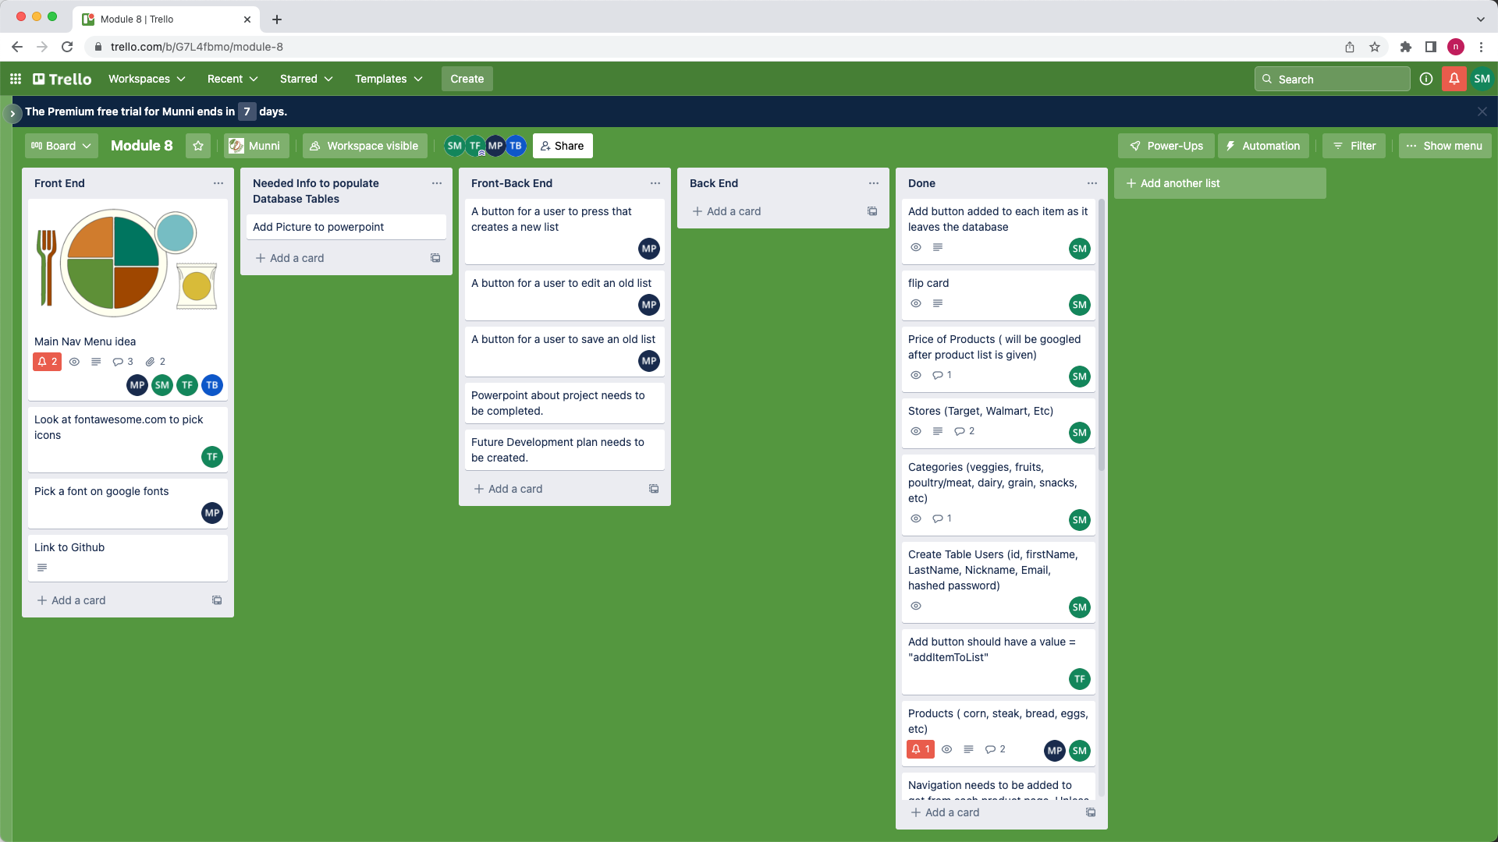
* Process for Writing, Deploying and Testing Code
  + Visual Studio Code
    - Coding PHP, HTML, CSS, JavaScript
  + Inspect tools in Chrome
    - Debugging
    - Troubleshooting
* Other Links
  + Module-8 Project
    - <https://github.com/Shehu-Muhammad/Module8-Grocery-Price-Checker>
  + Taylor Faber
    - <https://github.com/trfaber>
  + Tremar Bowden
    - <https://github.com/TBowden23>
  + Marlon Pierre
    - <https://github.com/mpierre24>
  + Shehu Muhammad
    - <https://github.com/Shehu-Muhammad>
  + Trello Link
    - <https://trello.com/b/G7L4fbmo/module-8>